ASK:

Problem:

An employer from a company who focuses on low sugar products has developed a new sweetener and wants to determine which product category possesses the most consumer demand for natural sweeteners so they know which business would be their ideal customers. They want you to find a dataset containing information on consumer purchases and use that dataset to determine which food product category has the most demand to produce items that are low in sugar.

1. What sweet goods are currently the most popular among consumers
2. What sweetened goods drive the most grocery sales
3. What platform is a good representative of consumer sales

Prepare:

1. The dataset used is one that contains data points pertaining to consumer purchases of online grocery store items from instacart. It is divided into six csv files organized in the form of rows and columns. These files include:
   1. Product.csv
   2. Aisle.csv
   3. Department.csv
   4. Orders.csv
2. Before being processed, the product dataset was uploaded onto excel and it’s contents were filtered to only include items that fall in sweetened goods categories. This was done by first filtering the aisle column and formatting the other columns to organize themselves with respect to the filter.

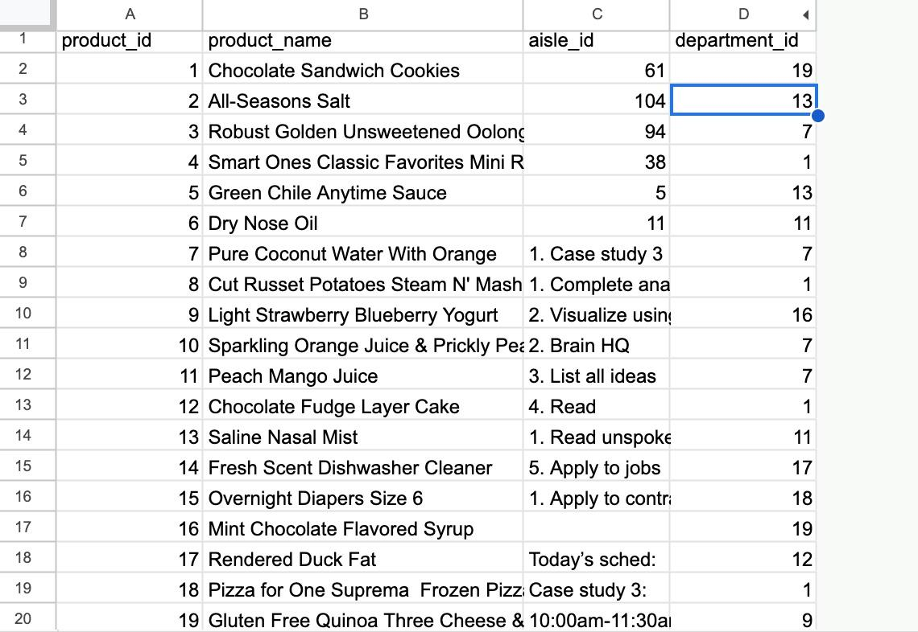

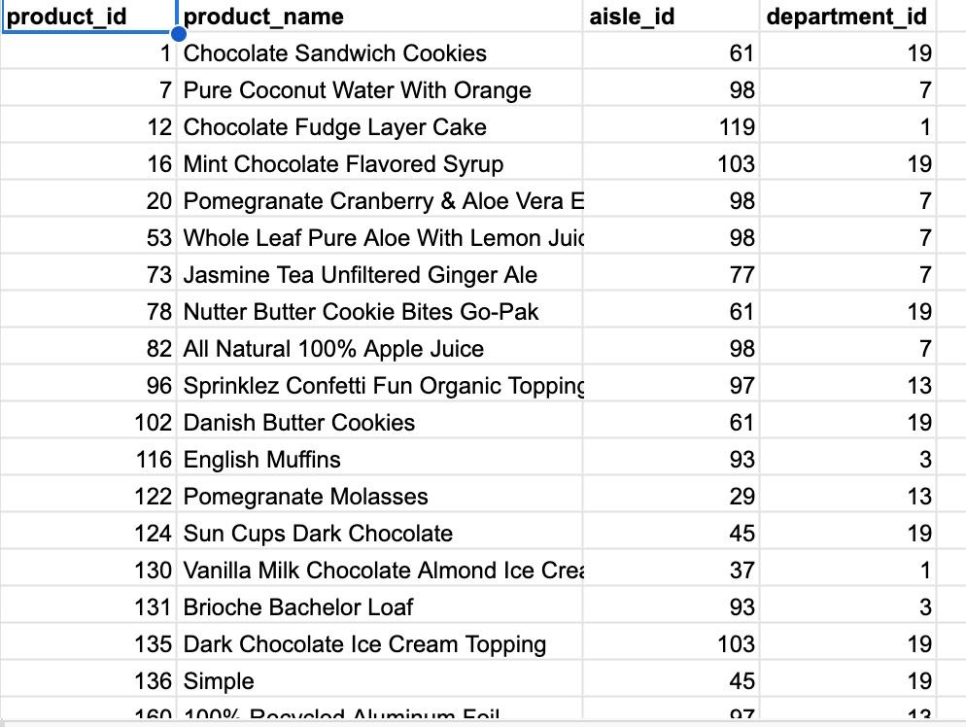

Initial results:

| Aisle | Average_Add_to_Cart_Orders |
| --- | --- |
| ice cream toppings | 10.82738095 |
| frozen juice | 10.54081633 |
| honeys syrups nectars | 10.13582402 |
| breakfast bars pastries | 9.700699746 |
| baking supplies decor | 9.549360146 |
| cookies cakes | 9.505711423 |
| air fresheners candles | 9.475164011 |
| baking ingredients | 9.365678484 |
| frozen dessert | 9.274403471 |
| refrigerated pudding desserts | 9.220358589 |
| ice cream ice | 9.128770506 |
| candy chocolate | 8.9320702 |
| cocoa drink mixes | 8.808851224 |
| breakfast bakery | 8.444523399 |
| juice nectars | 8.11358885 |
| bakery desserts | 7.519653564 |
| soft drinks | 6.808710609 |

The results from this table were then consolidated to include fewer categories as aisle names that clearly housed the same category of sweetened product were combined together and the average of both values were recorded (ex: ice cream toppings + ice cream, air freshener candies + candy chocolate). The final results are recorded in the table below:

| Aisle | Average_Add_to_Cart_Orders |
| --- | --- |
| ice cream | 9.74351831 |
| juice | 9.399770106 |
| baked sweets | 9.106918187 |
| candy | 9.203617106 |
| soft drinks | 6.808710609 |

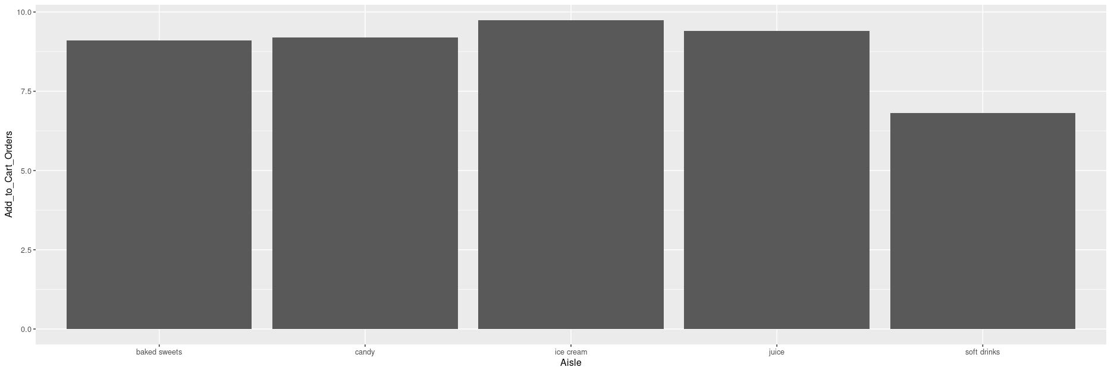

Conclusion:

The results of the analysis as indicated by the graph show that the most popular sweetened goods that consumers purchase pertain to the ice cream and frozen desserts category followed by juice, candy, baked sweets and soft drinks.

My recommendations:

1.The manufacturer as a result should focus on developing their business by first selling their product to popular and innovative ice cream brands and observe if they are able to generate a sizable revenue and profit from such a transaction before moving their efforts onto the second most popular, the third and so on and so forth.

2. The manufacturer should also expect the summer, fall and winter seasons to be their most profitable as the weather and seasonal holidays drive ice cream, juice, and candy (The top three products that are in most demand by consumers). As a result they should direct most of their marketing and inventory storage efforts to consumers and businesses during these times.

3. The business owner should also take into account that two income streams can be generated from both selling to businesses and to consumers. If products are targeted towards consumers than